- NEWS
9th September 2020
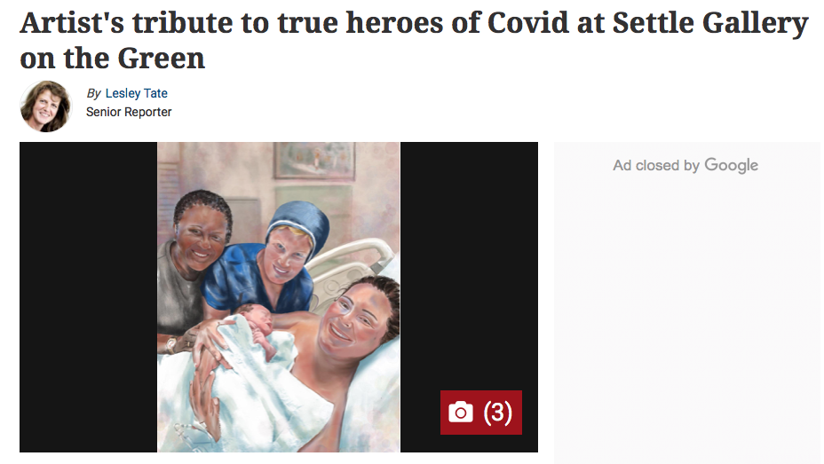

THE new exhibition, showing from Saturday at Gallery on the Green in Settle, honours the true heroes of the Covid-19 pandemic - the people who put their own safety at risk to look after us all.
Many of the portraits are of friends and former colleagues of the Settle-based artist Julie Sobczak.
Some are local, including a sheep farmer and his dog, but reflecting the fact that this is a global pandemic, they also include people who Julie has met during her extensive travels, that included a spell working as a midwife in the Cayman Islands.
Among the images is one of a group of musicians from New York who entertained neighbours during lockdown – the lead musician James Palmaro, who has been blind for 40 years, is a long- time friend of Julie’s.
Another image is of a policeman and his dog from New Zealand: they work with another of Julie’s friends. Naturally, health care workers in their protective gear feature in many of the images.
And reflecting Julie’s time as a midwife there is a picture of a family and their new born child with the midwife.
As an artist, Julie has previously worked mainly with watercolours but more recently has embraced the wizardry of technology to create these digital paintings, based on photographs, that strive not only to capture a likeness - but also give an insight into subject’s personality.
Julie said: “Thank you to all frontline workers. Your tireless efforts are not going unnoticed.”
Half of the donations made to the gallery during the exhibition will go to NHS Charities Together. Donations can be made by scanning the QR code in the exhibition posters or visiting the gallery website: www.galleryonthegreen.org.uk .
The exhibition at the gallery, which is based in a former telephone box in Upper Settle, and believed to be the world’s smallest art gallery, runs from Saturday, September 12 to November 6.
You can read more about Julie’s work at the website www.digitalartbrush.com.
The Upper Settle phone box was purchased by Settle Town Council in early 2009 under the BT ‘Adopt a Kiosk’ scheme. It is now an art gallery, is open all the time, and at least twice a day, is full to capacity - and how many art galleries can claim that?

